# **Name: Abdurrahman Qureshi**

# **Roll No: 242466**

Practical No: 7

1) Demonstrate the use of inbuilt functions in Haskell.

**OUTPUT:**

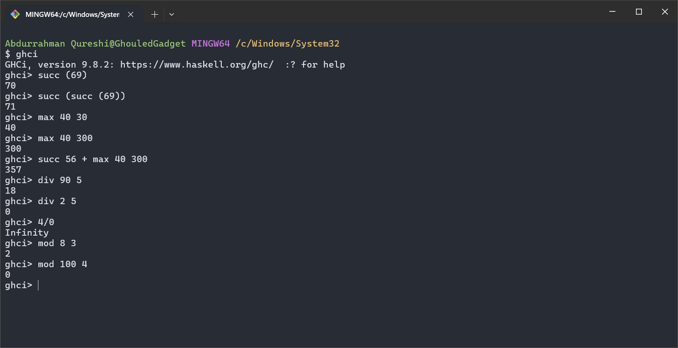

1) Create a Haskell script and print “Hello world”

**CODE:**

main :: *IO*()

main = do

    putStrLn "Hello, world!"

**OUTPUT:**

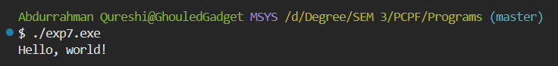

2) Basic arithmetic operations on integer

**CODE:**

main :: *IO*()

main = do

    putStrLn "Hello, world!”

**OUTPUT:**

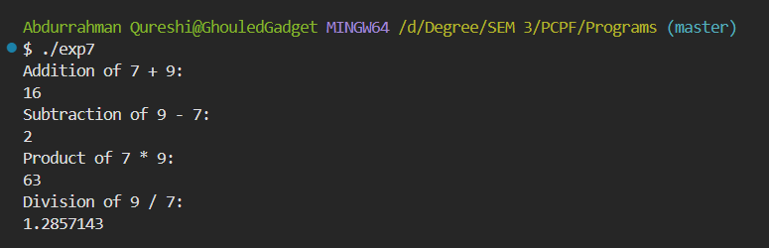

2) Basic arithmetic operations on floats

**CODE:**

main :: *IO*()

main = do

    putStrLn "Hello, world!"

**OUTPUT:**

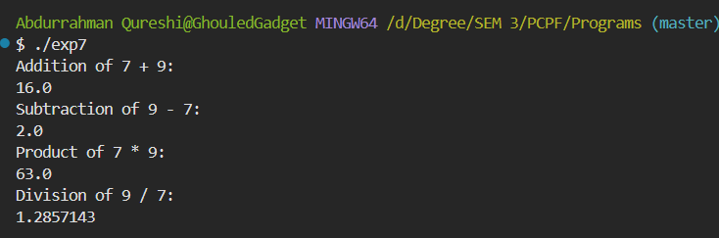

3) Print a user defined Fibonacci series

**CODE:**

main :: *IO* ()

main = do

    putStrLn "Enter the number of terms:"

    n <- readLn

    print (take n (fibonacci 0 1))

fibonacci :: *Int* -> *Int* -> [*Int*]

fibonacci a b = a : fibonacci b (a + b)

**OUTPUT:**

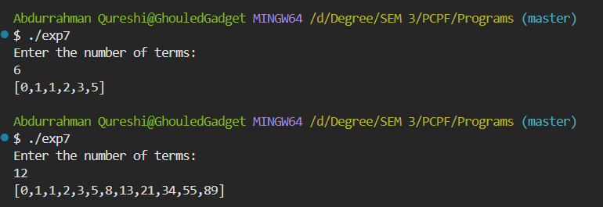

4) Use the map function on a list [1..5] to produce a list [2..6]

**CODE:**

main :: *IO* ()

main = print (map (+1) [1..5])

**OUTPUT:**

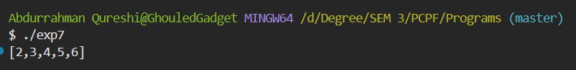

5) Use the map function on a list [1..5] to produce a list [2..6]

**CODE:**

main :: IO ()

main = print (map (*2) [1..10])

**OUTPUT:**

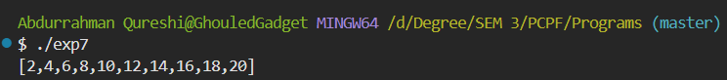

6) Use the map function on a list [1..5] to produce a list [2..6]

**CODE:**

main :: IO ()

main = print (filter odd [1..30])

**OUTPUT:**

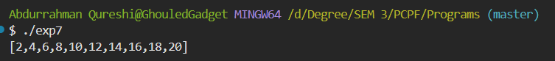

7) Use the map function on a list [1..5] to produce a list [2..6]

**CODE:**

main :: IO ()

main = print (filter (< 4) [1..10])

**OUTPUT:**

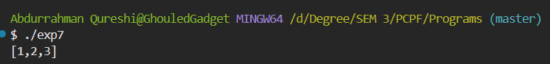

8) Haskell program To double a number

**CODE:**

main :: IO ()

main = print (filter (< 4) [1..10])

**OUTPUT:**

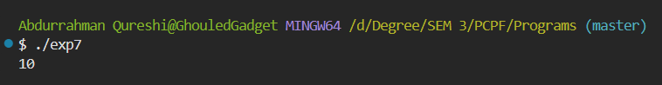

9) Haskell program To perform multiplication of 2 numbers

**CODE:**

main :: IO ()

main = print (filter (< 4) [1..10])

**OUTPUT:**

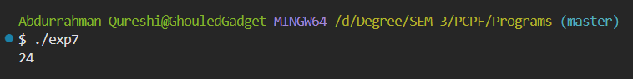

10) Haskell program To find the numbers in range 1 to 20 that are divisible by 3

CODE:

main :: IO ()

main = print (filter (< 4) [1..10])

**OUTPUT:**

